CLASS II RE-RESTORATION WITH COMPOSITE
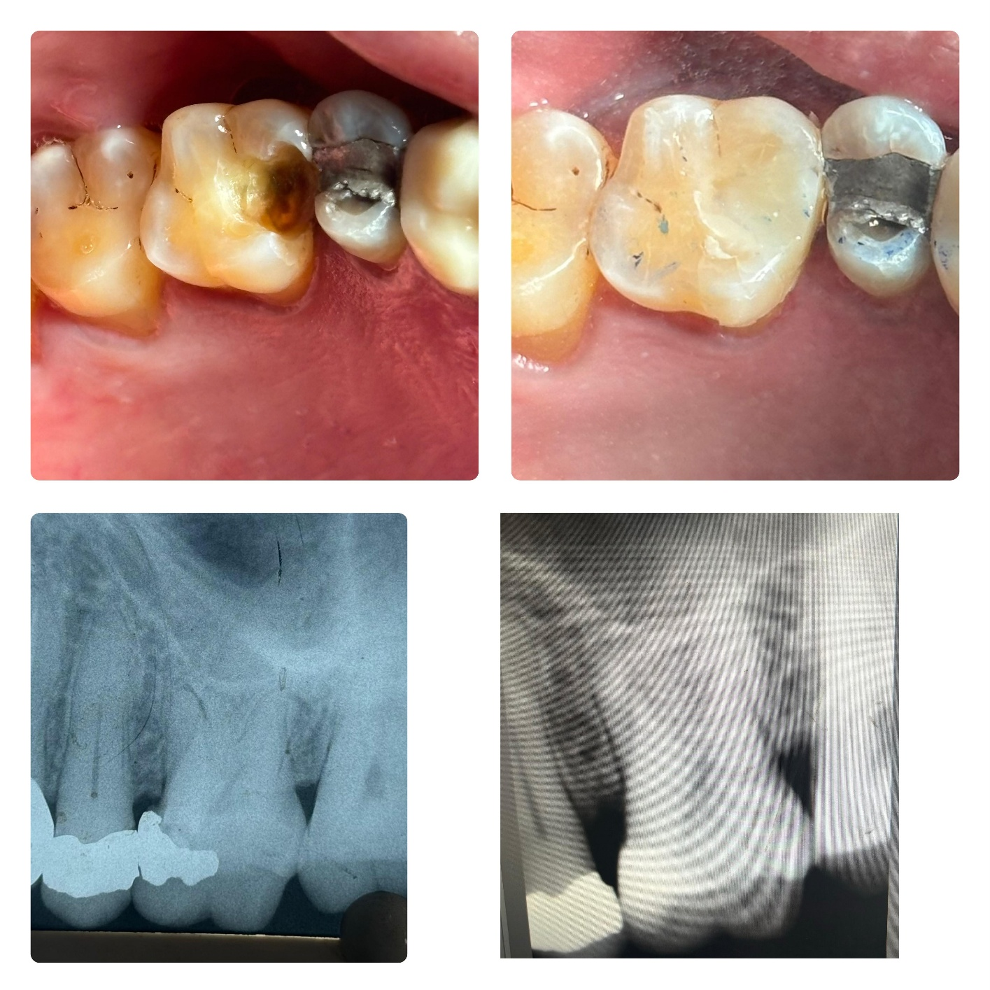

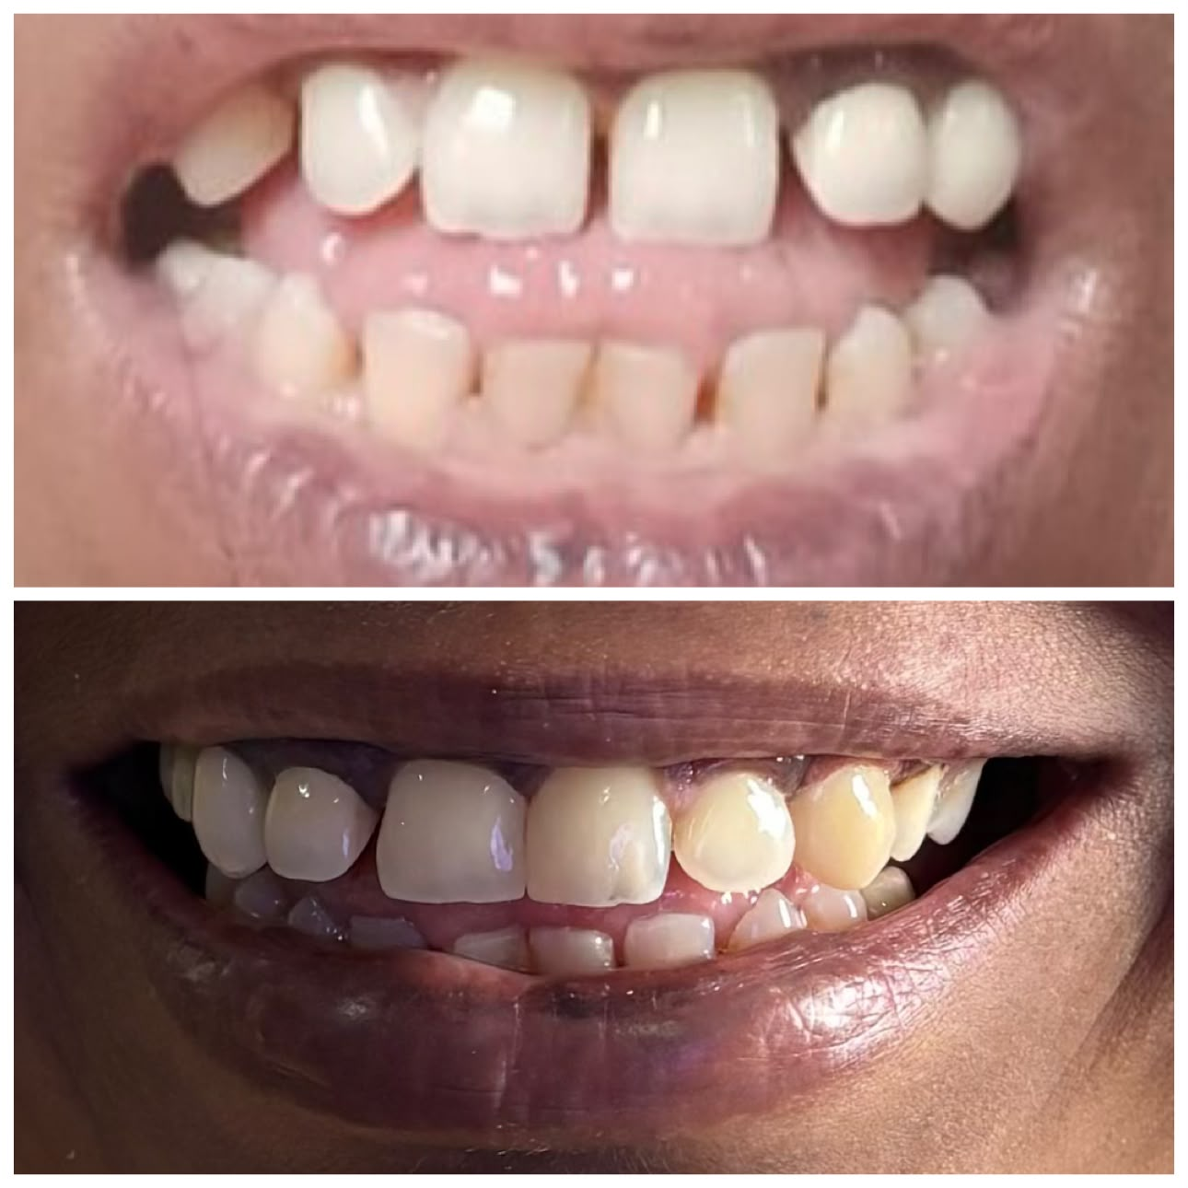
SPACE CLOSURE WITH COMPOSITE

PEG LATERALS BUILDUP WITH COMPOSITE

PRE-OP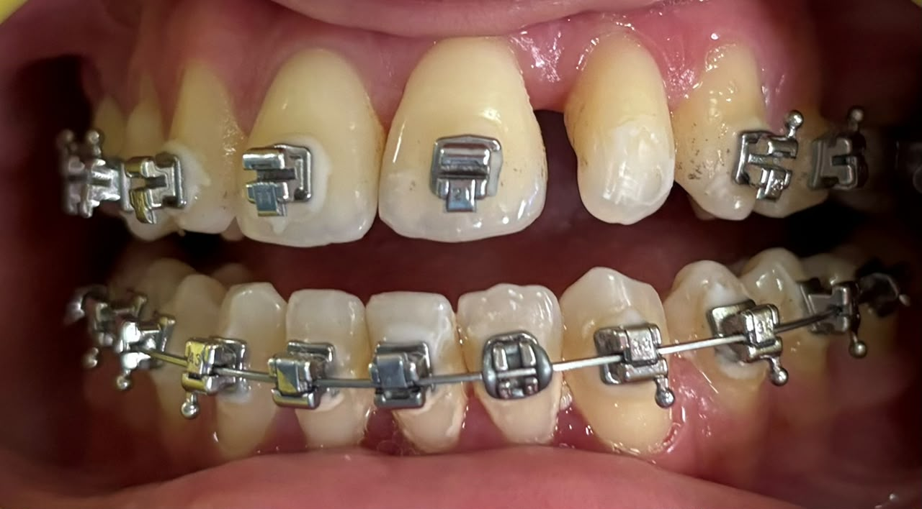

POST-OP
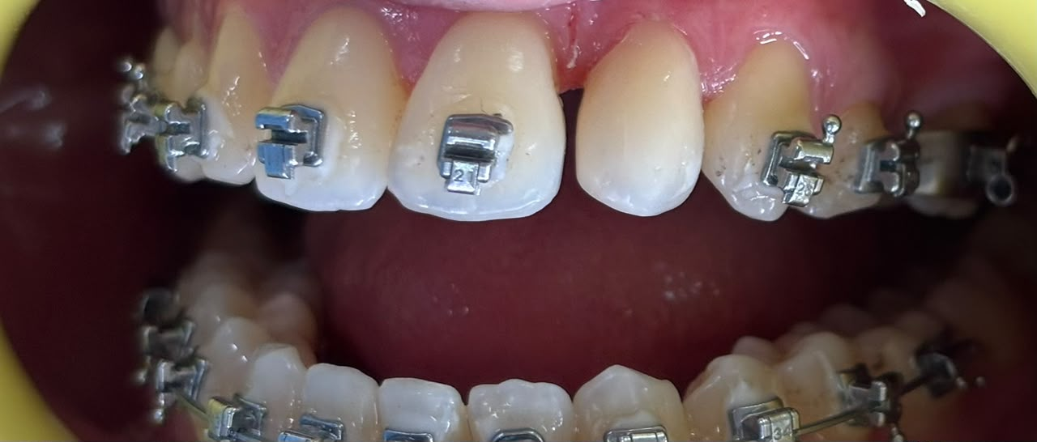

ENAMEL HYPOPLASIA

PRE-OP
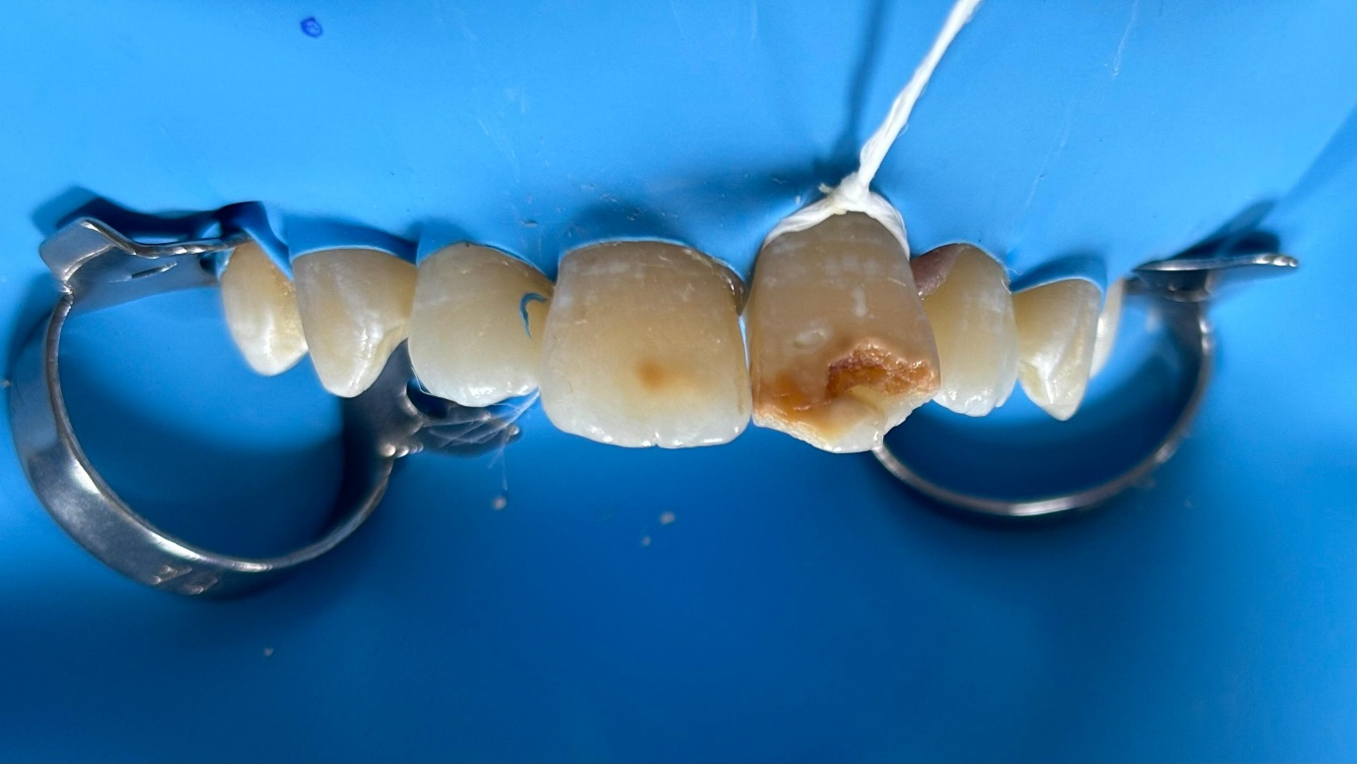

POST-OP
